**ntuaflix2023-17**

**Software Requirements Specification**

Version 1.0

# Revision History

|  |  |  |  |
| --- | --- | --- | --- |
| Date | Version | Description | Author |
| 15/12/2023 | 1 | Idk | Team |
|  |  |  |  |
|  |  |  |  |

# Table of Contents

Revision History 2

Table of Contents 3

Introduction 4

Purpose 4

Scope 4

Definition, Acronyms and Abbreviations 4

References 4

Overall Description 4

Problem Statement 4

Background 4

Objectives 4

Constraints 4

Functional Requirements 4

Use Cases 4

Requirements 5

User Requirements 5

Technical Requirements 5

Performance 5

Scalability 5

Security 5

Maintainability 5

Usability 5

Localization Support 5

Auditing and Logging 5

Availability 6

Hardware Requirements 6

Network 6

Client Computers 6

Deployment Requirements 6

Nodes 6

Components 6

Artifacts 6

Other Requirements 6

Appendices 6

# Introduction

This document provides a comprehensive overview of the software requirements for the ntuaflix service, an IMDb-like platform. It aims to clearly define the functionalities, interfaces, performance metrics, and design constraints of the system. The focus is on outlining the necessary requirements to ensure successful development and deployment.

## Purpose

The purpose of this document is to outline the system requirements for Ntuaflix, ensuring a shared understanding among stakeholders. It is intended to guide the development team in creating a system that meets end-user needs and to provide a clear understanding of the project's objectives and constraints.

## Scope

This document will discuss the Ntuaflix service, focusing on the requirements and specifications needed for its development. It will cover the stakeholders involved, the target audience, the existing systems, and the business processes that the new system aims to improve or replace.

## Definition, Acronyms and Abbreviations

RAID: Redundant Array of Independent Disks, a data storage virtualization technology that combines multiple physical disk drive components into one or more logical units.

|  |  |
| --- | --- |
| Term | Definition |
|  |  |

## References

A list of all the documents, articles, and resources referenced in preparing this SRS.

# Overall Description

## Problem Statement

Users currently face challenges with existing platforms, including limited functionalities, outdated interfaces, and performance issues such as slow response times and frequent downtime.

## Background

These problems stem from outdated technology, increased user traffic, and changing user needs, which the existing systems are not equipped to handle efficiently.

## Objectives

Our system aims to provide a comprehensive, user-friendly, and high-performance platform for movie enthusiasts to explore, rate, and discuss films, similar to IMDb but with enhanced features and a modern interface.

## Constraints

The Ntuaflix system will have certain limitations that need to be acknowledged. Firstly, the initial version of the platform may have scalability constraints, handling a limited number of concurrent users before performance degradation. Another limitation is platform dependency; the system will be optimized for Windows operating systems, with potential compatibility issues on other platforms. Additionally, there may be restrictions in integrating with certain third-party APIs, limiting some of the planned functionalities. Lastly, due to budget and time constraints, some advanced features like AI-driven recommendations might not be available in the initial release but are planned for future updates.

# Functional Requirements

Detailed description of key features like advanced search options, user profile customization, movie recommendation algorithms, and social interaction capabilities.

## Use Cases

### Use Case Diagram

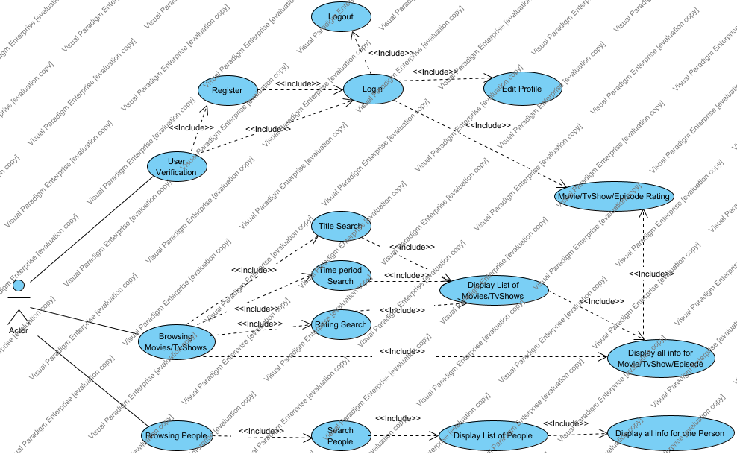

|  |  |
| --- | --- |
| Use Case | Description |
| Browsing Movies/TvShows | From the landing page, the user can see some of the movies/tvshows on display. (the movies/tvshows selected for the landing page will either be new or with a high rating score)  In the landing page there is the option to search by title, timeperiod or rating. |
| Browsing People | The user can choose the page where they browse actors/directors/writers.  The people shown in the page will be based on their popularity of their movies/tvshows |
| Display all info for Movie/TvShow/Episode | When a user chooses a tvshow/movie, then the page will return all the info for that movie/tvshow.  Additionally to that, if a user is logged in, they have the option to rate that movie  All info for a movie/tvshow/episode includes actors, writers etc. They user can select one of those people and view all their info |
| Display all info for one Person | While viewing the person's info, biography etc. The user also views the movies/tvshows they took part in, either as an actor, director, writer or anything else. If the user selects any of those movies they get redirected to the movie page where it displays all info for that movie. |
| Display List of Movies/TvShows | After filtering their movies/tvshows a list will be displayed with all the movies and tvshows that meet these criteria. |
| Display List of People |  |
| Edit Profile |  |
| Login | The options that the user has after logging in are rating and changing their password.  They have all the other functions than if they dont login. |
| Logout |  |
| Movie/TvShow/Episode Rating | The user, after logging in and after finding the movie that they are looking for, they have the choice to rate the movie on a scale from 1 - 10.  The rating of that movie will change accordingly.  This action cannot happen if the user isn't logged in, since if we could allow people who aren't logged in to rate, "ζήτω που καήκαμε" |
| Rating Search |  |
| Register | The user after registering, they need to login with their credentials |
| Search People | Search people by name, in result you will get a list of all the writers, actors, directors that have a similar name |
| Time period Search |  |
| Title Search |  |
| User Verification | The user has the choice to login in their own profile, or create a new account.  Also, editing the profile means that they can only change their password. |

## Requirements

|  |  |
| --- | --- |
| Requirement | Description |

# User Requirements

The system is designed for movie enthusiasts, film critics, industry professionals, and general audiences who seek a platform to explore and discuss films. It will be accessible on various devices and adaptable to different user environments.

|  |  |
| --- | --- |
| Actor | Description |
| Actor |  |

# Technical Requirements

## Performance

## Scalability

## Security

## Maintainability

## Usability

## Localization Support

## Auditing and Logging

## Availability

# Hardware Requirements

Minimum and recommended hardware specifications for running the system, including processor speed, memory, storage, and network requirements.

## Network

## Client Computers

# Deployment Requirements

## Deployment Diagram

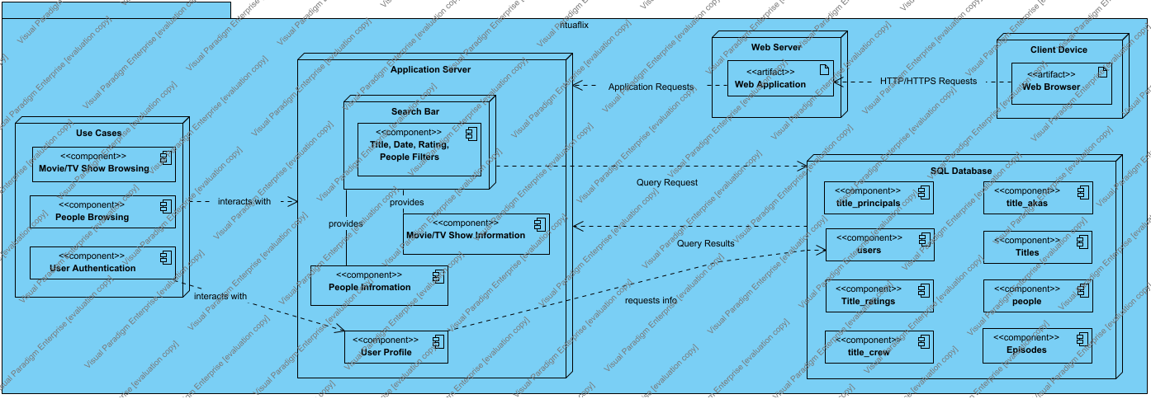

## Nodes

|  |  |
| --- | --- |
| Name | Description |
| Application Layer |  |
| Application Server |  |
| Client Device | Represents the end-user devices such as smartphones, tablets, or computers through which users interact with the web application using a web browser. |
| Search Bar |  |
| SQL Database |  |
| Use Cases |  |
| Web Server | Acts as the intermediary between the client devices and the application server, handling HTTP/HTTPS requests and responses. |

## Components

|  |  |
| --- | --- |
| Name | Description |
| Component3 |  |
| Database: People | 1. Maintains records of actors, directors, and other movie industry professionals. 2. Includes biographical data, filmography, and professional milestones. |
| Database: People | 1. Links with other databases to provide a relational context between actors/writers/directors. |
| Database: Titles | 1. Stores extensive information about movies and TV shows, such as titles, release dates, genres, and ratings. 2. Links with other databases to provide a relational context between movies, actors, and user ratings. |
| Database: User | 1. Central repository for storing user information, including login credentials and profile data. 2. Supports CRUD operations (Create, Read, Update, Delete) for user accounts. 3. Implements security measures to protect sensitive user data. |
| Database: User Ratings | 1. Stores user feedback on movies, including likes/dislikes and personalized ratings. 2. Allows for dynamic updates to user ratings and maintains a history of user interactions with movie titles. |
| Episodes | Details individual episodes within a TV series, including episode-specific information and parent-child relationships to titles. |
| Interaction Service | 1. Manages user interactions with the system, specifically related to movie ratings. 2. Updates movie ratings based on user input and recalculates aggregated scores. 3. Analyzes and suggests connections between movies and cast members based on user activities and preferences. |
| Movie Service | 1. Facilitates searching and retrieving movie-related information. 2. Offers detailed view services for movies, including synopses, ratings, and cast details. 3. Integrates with actor/cast search to provide comprehensive data about movie personnel. |
| Movie/TV Show Browsing | Enables users to search and browse through the catalog of movies and TV shows. Supports various filters and sorting options to enhance the user experience. |
| Movie/TV Show Information | Aggregates and serves detailed information about movies and TV shows, including synopses, cast lists, ratings, and multimedia assets like posters. |
| people | Stores information about actors, directors, and other contributors, linked to their respective works |
| People Browsing | Allows users to look up actors, directors, and other film personnel. Provides detailed information like biographies, filmographies, and related media. |
| People Infromation | Manages and displays comprehensive information about film industry personnel, including career details, personal biographies, and lists of associated works. |
| People Service | 1. Facilitates searching and retrieving people-related information. 2. Offers detailed view services for actors/directors/writers |
| Title, Date, Rating, People Filters | Provides a user interface element for submitting search queries. Supports advanced search features such as filtering by title, date, rating, and people involved. |
| title_akas | Contains alternative names for titles, accommodating different languages and regional distributions. |
| title_crew | Associates crew members with titles to display accurate credits for movies and TV shows. |
| title_principals | Maintains the list of key personnel involved in a production, including lead actors and key crew members. |
| Title_ratings | Holds rating information provided by users, used for generating recommendations and rankings. |
| Titles | Contains metadata about each movie or TV show, including title names, release dates, and genres. |
| User Authentication | Handles user login processes, including credential verification, session management, and security checks. Responsible for user registration and maintaining the integrity and confidentiality of user credentials. |
| User Profile | Manages individual user profiles, allowing users to view and edit their personal information, preferences, watchlists, and interaction history. |
| User Service | 1. Handles all user-related operations such as registration, authentication, and profile management. 2. Ensures secure storage and retrieval of user credentials. 3. Provides interfaces for users to manage their personal details and preferences. |
| users | Stores user account information, including authentication details and user preferences. |

## Artifacts

|  |  |
| --- | --- |
| Name | Description |
| Web Application | Serves as the front-end user interface of the service. Built to deliver a responsive and intuitive user experience across various devices and platforms. |
| Web Browser |  |

# Other Requirements

# Appendices